**Oracle Administration Services**

**User Creation on MDMS Databases**

Submitted to



**By**



CIS, Wipro Limited

Document Details

|  |  |
| --- | --- |
| Project Name | Innogy SE |
| Account | CIS |
| IT Component/Application Title | User creation on MDMS database. |
| Current Version | 1.2 |
| List of Contributors | Sreya Puthukudy |
| Customer Contact Information |  |

Version History

(All revisions made to this document must be listed in chronological order. All revisions must be approved. Review and Approval can be done by an internal source or by the customer)

|  |  |  |  |  |  |
| --- | --- | --- | --- | --- | --- |
| Version | Date of Revision | Description | Author | Reviewed By | Approved By |
| 1.0 | 28-11-2017 | Initial Draft | Sreya Puthukudy | Jitenkumar Pansara | Mahesh Keshatwar |
| 1.1 | **30-11-2017** | **Document Completed** | **Sreya Puthukudy** | **Jitenkumar Pansara** | **Mahesh Keshatwar** |
| 1.2 | **30-12-2018** | Updated the content | Sreya Puthukudy | Jitenkumar Pansara | Santosh Badiger |

Document Distribution List

|  |  |  |
| --- | --- | --- |
| **S.No** | **Name and Company** | **Purpose** |
| **1** | RWEIT-ORACLEDBA | **This document is about user creation on MDMS database** |
| **2** |  |  |

**TABLE OF CONTENT**

1. Purpose 5

2. Scope 5

3. Steps to create user on MDMS database 5

# Purpose

This document is prepared for |:dg&hx ja)Mz0the user creation on MDMS database.

# Scope

This document is prepared for RWE GBS UK Wipro sustenance team and provides the steps to create user on MDMS database.

# Steps to create user on MDMS database

1. UK_ORACLE team will receive a SNOW request for MDMS user creation with the short description as **CREATE SIEBEL DB user role**
2. In the SNOW request, there will be two tasks; One for UK_ORACLE team and One for IBM_AMS_ENERGYIP team. Task will be taken care by each team respectively. Note: There is no dependency among the task.

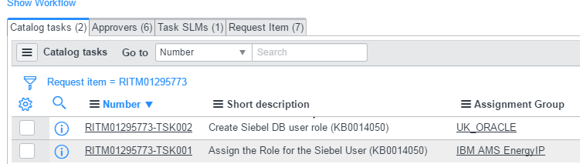

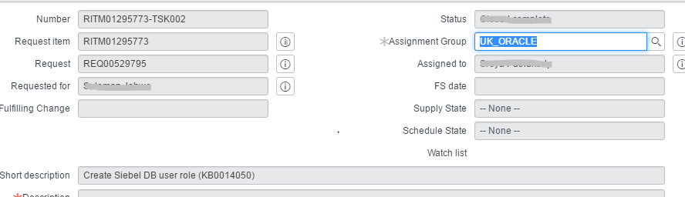

1. Every SNOW request will contain a Knowledge Base Article attached to it for eg: KB0014050
2. Open the Knowledge base in SNOW

Steps: Type the Knowledge base number in the search bar of SNOW , you will get the article as shown below:

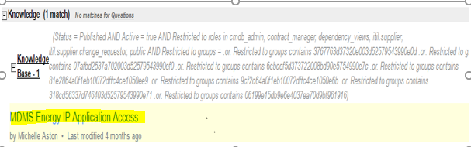

1. Knowledge Base will contain Model ID, Database Name (Environment details).

**Note**: If any Model ID is provided in the request, which is different from the ones in KB, please reconfirm with the user.

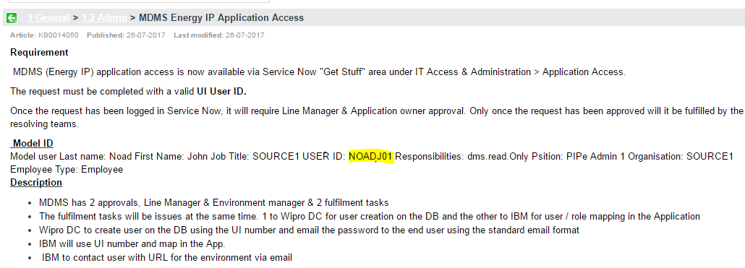

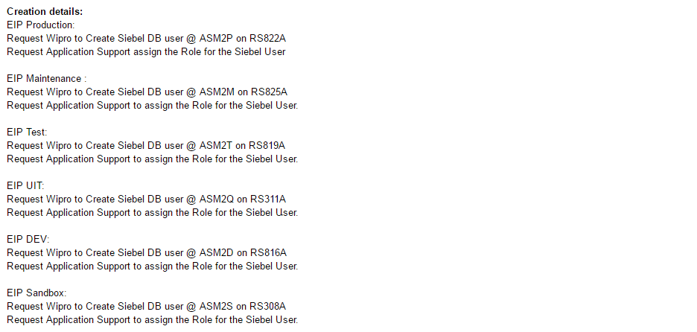

1. As per the Environment mentioned in the request, fetch the Database Name from the Knowledge Base.

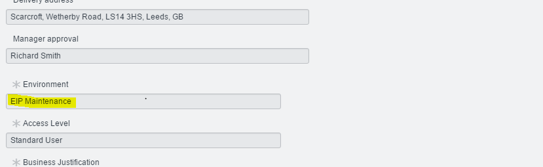

1. User ID that needs to be created on the database can be fetched by clicking “i” button near the ‘Requested for’ column in the request.

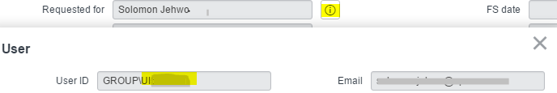

1. After user creation on the required database as per the requirement, **Send mail to user in the below format ONLY.**

**MAIL FORMAT AS PER BELOW:**



1. After sending the mail Closed complete the request with the closure notes as “User has been Created “ in the work notes. There is no requirement to follow three-strike rule.

**Do not update the closure notes in ADDITIONAL COMMENTS section.**

